Early Literacy Summer Reading Program 2021:
Tails & Tales
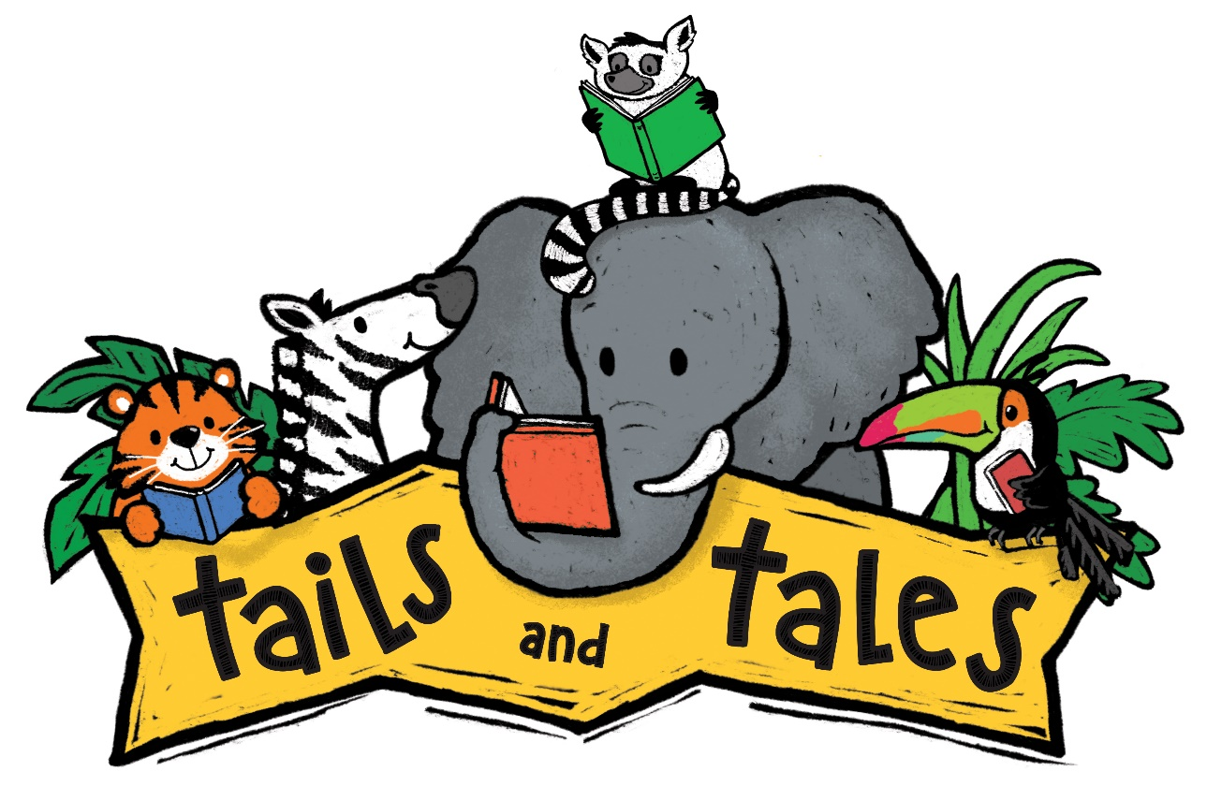
- Summer reading kickoff party June 12 11-1 join us for Games, lunch, and a visit with Elsa and Captain America! AT EDCO PARK
- Meet at Moraine's Butterfly Trail at 10:00 a.m. to Discover Moraine's exciting self-guided trail and learn about the area's native plants and butterflies, some of which are endangered species. Enjoy the pond, bridges, arbor, gazebo and boardwalk as you make your way along the trails. During your hike, complete a scavenger hunt and look for signs and educational kiosks that explain what you are observing.
- Bring home some family fun with a Grab and Go Steam Kit (Science, Technology, Engineering, Art, and Math) Available June 28th and July 19th
- Spend the morning with some wild animals at Living Treasures Animal Park! Fun for the whole family! Please register for this event! Limited number of passes will be available! We will meet at the park at 10:00 on June 30. Please bring a packed lunch. Passes are limited to one adult and children. Additional passes may be purchased at the park for $7.99.
- Join us July 14 from 11-12 at the library for some farm animal fun with 4-H as we learn about farming and where our food comes from!
- Storytime at Edco Park every Thursday from 11-11:45 except the week of July 4th. Bring a blanket or some chairs in case the pavilion is occupied. In case of bad weather meet at the library.
- End of Summer Reading Party August 2nd from 11:30-1:30 at Edco Park!

Register for the summer reading Program on our website at www.evanscitylibrary.org

